**Solutions to Intermediate and College Algebra by Rhodes**

**Section 1.1**

|  |  |
| --- | --- |
| 1. 20  2. -21  3. 105  4. -5  5. 18  6. -3  7. 65/2 = 32.5  8. -36  9. $\frac{-539}{208}≈-2.591$ 10. 13/3  11. 81  12. $\sqrt{60}=2\sqrt{15}$ $≈7.746$ 13. -2  14. -1/3  15. -1 | 16. 40  17. 67  18. $\sqrt{39}-10 ≈-3.755$ 19. 4.7 x 105  20. 1.512 x 109  21. 3.41 x 10-6  22. 6 x 10-4  23. 0.0000154  24. 39000  25. 4000  26. -0.0000021  27. 2,050,000,000 = 2.05 $×$ ${10}^{9}$ 28A. 55103400 ft3  B. 412173432 gallons or 4.1217 x 108 gallons  29A. 1.112228 x 1013  B. $35421.27 per person |

**Section 1.2**

|  |  |
| --- | --- |
| 1. x = 3  2. x = -13/3  3. x = 17/2 = 8.5  4. x = 80  5. x = -3/8  6. x = 17/8 | 7. x = 7/5  8. x = $-\frac{108}{55} ≈$-1.964  9. No solution  10. t = -48/19  11. x = -1/4 = -0.25  12. All real numbers or infinite number of solutions |

|  |  |
| --- | --- |
| H (hours) | D (in miles) |
| 0 | 250 |
| 1 | 195 |
| 2 | 140 |
| 3 | 85 |

13A. B. D = 250 – 55h C. yes; because D = 250 – 55(3) = 85 miles

14A. 159/14 $≈$ 11.357 gallons B. 392 miles

15A. 675 people B. During 2001

16. x = -1

17. x = 4

|  |  |  |  |  |  |
| --- | --- | --- | --- | --- | --- |
| x | -2 | 0 | 2 | 4 | 6 |
| 2x+5 | 1 | 5 | 9 | 13 | 17 |

18. x = -2

|  |  |  |  |  |  |
| --- | --- | --- | --- | --- | --- |
| x | -3 | -2 | -1 | 0 | 1 |
| 2-3(5x+4) | 35 | 20 | 5 | -10 | -25 |

|  |  |
| --- | --- |
| 19. x = -1  20. x = 5  21. x = 0  22. y = 2x – 5  23. L = $\frac{A-2w^{2}}{4w}=\frac{A}{4w}-\frac{w}{2}$ | 24. t = $\frac{A-P}{Pr}$ = $\frac{A}{Pr}-\frac{1}{r}$ 25. x > 4 (4, ∞)  26. x ≥ 6 [6, ∞)  27. x > -2 (-2, ∞)  28. x ≤ 5/6 (-∞, 5/6] |
| 29. -1 < x ≤ 7 (-1, 7]  30. -9/2 < x < -19/6 (-9/2, -19/6)  31. x > 5 (5, ∞)  32. x ≥ -5/2 $\left[-\frac{5}{2}, ∞)\right.$ | 33. x < 3  34. x $≤$ 0.25  35. x < 2  -2  0  2  4  **(**  **]**  36. (-2, 4] |

37. a. x = 2.5, b. x = 1, c. , d. 38. a. x = 6, b. x > -3, c.

39. a. x = 6, b. x < 6

**Section 1.3**

|  |  |
| --- | --- |
| x | y |
| 0 | 3 |
| 6 | 0 |
| -2 | 4 |
| 8 | -1 |

|  |  |
| --- | --- |
| x | y |
| 0 | -1 |
| 2 | 3 |
| -2 | -5 |
| -1 | -3 |

1. 2.

|  |  |
| --- | --- |
| x | y |
| 0 | 4 |
| 8/3 | 0 |
| 2 | 1 |
| 4 | -2 |

|  |  |
| --- | --- |
| x | y |
| 0 | 1 |
| 1/2 | 0 |
| 4 | -7 |
| 5 | -9 |

3. 4.

|  |  |
| --- | --- |
| x | y |
| 0 | 4 |
| -8 | 0 |
| -4 | 2 |
| 8 | 8 |

5.

6A. Approximately 50 students B. 12 minutes C. at least 25 students

7A. $3.90 B. $2.70 C. 1975 and later

D. 1990 to 1991 E. about 50 or 60 cents

8A. y = 2/3 x – 3

B. Horizontal intercept or x-intercept: (9/2, 0)

Vertical intercept or y – intercept: (0, -3) C. Window:

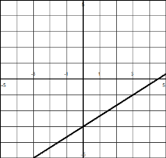

9. L- intercept: (45, 0); W-intercept: (0, 30); Window: [0, 45, 4] [0, 35, 5]

10. x-intercept: (-8, 0); y-intercept: (0, 6); Standard Window

11. c-intercept: (700, 0); P-intercept: (0, 200); Window: [0, 800, 100] $×$ [0, 250, 50]

12. x-intercept: (1/10, 0); y-intercept: (0, 2/35); Window: [0, 1, 0.1] $×$ [0, 0.1, 0.01]

13A. At 4°C, the ant speed is 0.

B. [0, 30, 5] x [0, 5, 1]

|  |  |  |  |  |  |
| --- | --- | --- | --- | --- | --- |
| x | 1 | 3 | 7 | 12 | 21 |
| y | -.51 | .057 | 1.2 | 2.63 | 5.2 |

14A.

B. [0, 22, 5] x [ -2, 7, 1]

15A. R = 35 – 0.6w B. 29.6 lbs

C. (58.33, 0) After 58 1/3 weeks, the rice is gone.

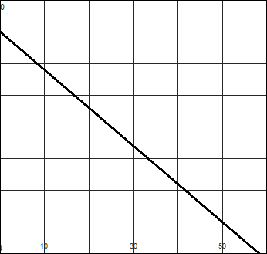 D. (0, 35) At 0 weeks, there is 35 pounds of rice. E. [0, 60, 10] $×$ [0,40,5]

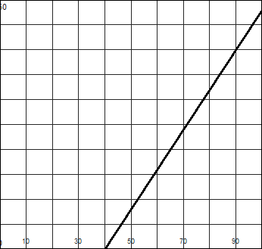16A. 200 B. 51.25°F C. Yes. At 60°, the cricket chirps 80 times per minute.

D. (40, 0) At 40°F, the crickets don’t chirp.

E. (0, -160) No, negative chirps is unreasonable.

F. [0, 100, 10] x [0, 250, 25]

G.

17A.

|  |  |  |  |  |  |
| --- | --- | --- | --- | --- | --- |
| t | 0 | 1 | 3 | 4.5 | 6.25 |
| V | 25000 | 21500 | 14500 | 9250 | 3125 |

B. [0, 8, 1] x [0, 25000, 5000]

|  |  |
| --- | --- |
| 0 | 65 |
| 5 | 95 |
| 8 | 113 |

18A.

B. T = 65 + 6h C. h = 4.167 hours or around 10:10 am

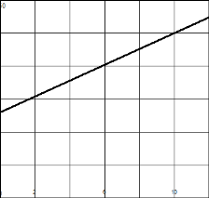D. Window: [0, 12, 2] $×$ [0, 150, 25]

**Section 1.4**

1. F = 35 + 54.99m

(0, 35) Initial fee is $35 for 0 months.

(-0.64, 0) Not reasonable, negative months.

2. D = -350 + 15m

(0, -350) He starts at 350 feet below sea level.

(23.33, 0) After 23.33 minutes, he is at the surface (0 feet below sea level).

3. B = 50 – 0.75w

(0, 50) He has 50 pounds at week 0.

(66.67, 0) After approximately 66.67 weeks, the rice is gone.

4. W = 7.50h

(0, 0) If he works 0 hours, he makes $0.

5A. F = 2.70 + .23(t-1) where t is in 1/10 of a mile B. F = $13.97

C. t = 37 or 3.7 miles D. t = 113.2 or 11.32 miles

6A. W = 250 + 0.07s B. W = $509 C. s = $5000

7A. C = 750 + 32y; C = 900+18y B. approximately 10.71 years

8A. A = P + 0.175P = 1.0175 P B. $7631.25 C. $982.80

9A.

|  |  |  |  |  |  |  |  |
| --- | --- | --- | --- | --- | --- | --- | --- |
| a | -500 | 0 | 1000 | 2000 | 3000 | 4000 | 5000 |
| B | 213 | 212 | 210 | 208 | 206 | 204 | 202 |

B. B = 212-0.002a C. [-500, 5000, 500] x [200, 215, 1] D. a > 4000; (4000, ∞)

10A. times in minutes when plan B is cheaper; t: time in minutes

B. Plan A: 0.20t

Plan B: 9.99 + 0.16t

C. t > 249.75 minutes

**Section 1.5**

|  |  |
| --- | --- |
| 1A. yes B. no  2A. no B. yes C. no  3. yes  4. yes | 5. no  6. yes  7. no  8. no |

9A. -23 B. 289 C. 5h6 – 8h2 + 1 D. 5t3 – 8t – 2

10A. 3 B. C. + 1= D. 3

11A. 68 B. 12 C. 3a2 – 5a – 11 D. 3x2 + 6xh – 5x + 3h2 – 5h

12A. -1 B. 9 C. t = 2

13A. -1 B. 3 C. -1.5 D. -2.5

14A. 7x + 6 B. 5x – 8 C. 253 D. $\frac{6x-1}{x+7}$

E. 6x + 41 F. -6

15A. 22 B. x2 – 2x – 7 C. 2x3 + 7x2 D.

E. 81 F. 2x2 + 7

16A. -3 B. -5.5 C. -18 D. -1.75 E. -4

17A. -6 B. -2 C. 45 D. 1

18A. S(3) = 4000 After 3 weeks, there are $4000 in sales.

B. Between weeks 5 and 11.

C. Week 8, $12500

19A. July, 74°, T(7) = 74

B. approximately 43; In April, the average high temperature is 43°.

C. January-March and November-December

20. f(x) = ; g(x) = 3x2 + 4

21. f(x) = x5; g(x) = x2 + x + 1

22. f(x) = ; g(x) = 2x – 1

23. f(x) = 5x; g(x) = 3x + 1

24. f(x) = ; g(x) = 2x + 3

25. f(x) = ; g(x) = x2

26. A. 4a + 4h + 7 B. 4h C. 4

27. A. a2 + 2ah + a + h2 = h B. 2ah + h2 + h C. 2a + h + 1

28. A. B. C.

29. A. a3 + 3a2h + 3ah2 + h3 – 1 B. 3a2h + 3ah2 + h3 C. 3a2 + 3ah + h2

30. (f ◦ g)(x)=; Domain: x ≠ 0, x ≠ ½

31. (f ◦ g)(x) = + 3; Domain: x ≥ 0

**Unit 2**

**Section 2.1**

|  |  |
| --- | --- |
| 1. 3.5 miles per gallon  2. $3.59 per gallon  3. $15 per month  4. m = 3  5. m = 0  6. m = -3/4  7. m = -$50 per month  8. m = 8  9. m = 150 people per year  10. m = -30 ft/min | 11. m = $12/hour  12. m = 13/6  13. m = 5/3  14. m is undefined  15. m = 0  16. m = -17/9 or m $≈-1.89$ 17. C  18. A  19. D  20. B |

**Section 2.2**

|  |  |
| --- | --- |
| 1. y = -7x – 1  2. y = 2/7 x + 2  3. y – 1 = -5/2(x - 3) or y = -5/2 x + 17/2  4. y = 2/5 x + 27/5  5. y = -5/6 x + 3  6. y = 4  7. x = 3  8. y = 5  9. y = -2x + 1 | 10. y = ½ x + 4  11. y – 2 = ¾ (x – 1)  12. y – 3 = -5/2(x – 1)  13. m = 20h + 30  14. f = -3/2 s + 75  15. h = -30t + 120  16. y = 25x  17. y = 2/3x + 12  18. P – 21 = -21/26(t - 2002) |

19A. m = $8.50 per pound; Candy costs $8.50 per pound.

B. (0, 4) It costs $4 for 0 pounds.

C. C = 8.50p + 4

20A. m = 0.09 Median age increases by 0.09 years per year.

B. (0, -147.1) Negative years does not make sense.

21A. m = -1°/200 ft The temperature decreases by 1° for every 200 ft above sea level.

B. (0, 80) The temperature at sea level is 80°.

C. T = -1/200 A + 80

22. C

23. B

24. C

25A. III B. II C. I D. IV

|  |  |
| --- | --- |
| 200 | 200 |
| 500 | 350 |
| 1000 | 600 |

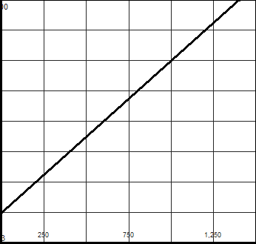26A.

B. C = 100 + 0.50N

C. see graph

D. [0, 1500, 250] x [ 0, 800, 100]

|  |  |
| --- | --- |
| 27. y = 5x + 1  28. y = -1/2 x – 2  29. y = -3 | 30. y = -4x +9  31. y = x + 11  32. x = -6 |

**Section 2.3**

**Answers may vary.**

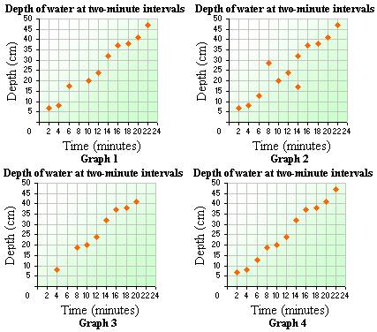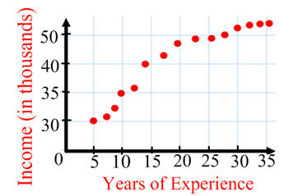

1. 2.

Points: (10, 35) (25, 48) Points: (4, 10) (14, 30)

I – 35 = 13/15(E – 10) D – 10 = 2(m – 4)

3. 4.

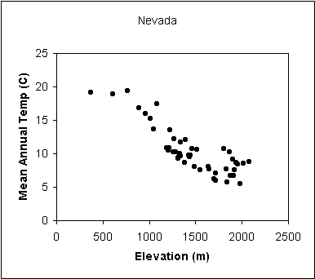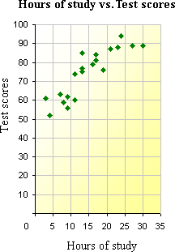

Points: (5, 60) (25, 90) Points: (0, 24) (2500, 2)

T – 60 = 3/2 (H – 5) c = -11/1250m + 24

5 – 8. Answers will vary.

9. K = 5/9 F + 255.222

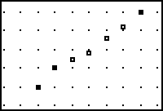

10

8

12

14

B

70

50

P

60

10. Points: (11, 60) (14, 70)

P – 60 = 10/3 (B – 11)

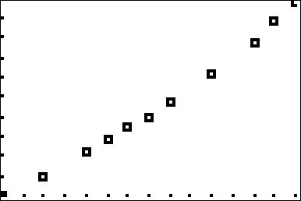11A. scatterplot

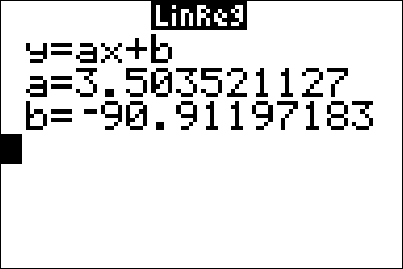11B.

11C. 3.5 lbs. per in in height

11D. -90.91. No, negative height doesn't make sense.

11E. at 61 inches the weight could be 122.8 lbs.

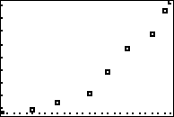12A.

12B. The graph does not appear to be linear.

**Section 2.4**

|  |  |
| --- | --- |
| 1A. x = 3 B. x ≥ 3  2A. x = -3 B. x = 3 C. x > 6  3A. x = 2 B. x < 2  4. x $≈$ 2.82  5. x = -3 | 6. x = -4  7. x = -6  8. x ≤ 2  9. x > 5.6 |

10A.

|  |  |  |
| --- | --- | --- |
| Amount of Product | Company A Profit | Company B Profit |
| 20,000 | 1500 | 800 |
| 45,000 | 4000 | 5000 |

B. A C. B D. 30000 units, $2000 profit E. more than 30000 units

11A. Scatter plot

**Section 2.5**

1. 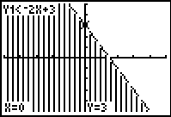 2. 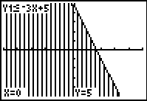

3. 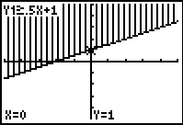 4. 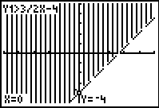

5. 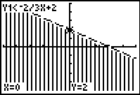 6. 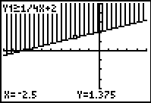

7. 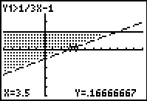 8. 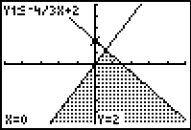

9. 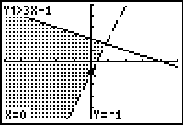 10. 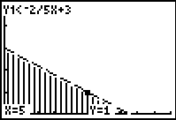

11. y > x + 1 12. y ≤ x – 1

13. y ≥ -2x – 1 14. y > -x – 2

15. 0.75x + 0.60y ≥ 25, x ≥ 0, y ≥ 0 16. S + C ≤ 150, 297S + 412C ≥ 55000, S ≥ 0, C ≥ 0

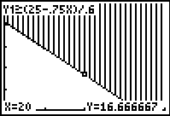 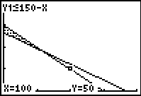

**Section 2.6**

|  |  |
| --- | --- |
| 1. (4, -1/2)  2. (-2, 1)  3. (1, -1)  4. (-2, 0)  5. (2, -5) | 6. (-1, 1)  7. (5/7, -26/7)  8. (28/19, -13/19)  9. 1991 |

10. 7N + 4P = 6.40 ; 2N + 19P = 5.40

N = 0.80, P = 0.20 Notebooks are $0.80 and pens are$0.20.

11A. 3B + 2E = 7.45; 2B + 3E = 6.45

B. E = 0.89, B = 1.89 $5.56 is the amount returned.

12. (2, -1/2) intersection point

13. $7500

14. 37.5°, 52.5°

15. 8 inches by 12 inches

16. 1.3 liters of water and 0.2 liters of hydrogen peroxide

17. 90.9 pounds of dog food A and 409.1 pounds of dog food B

18. $25000, $50000

19. $5600, $18000

20. No solution; inconsistent; independent

21. Infinite solutions; consistent; dependent

22. x = -5/3, y = -1/3; consistent, independent

23. x = 21/11, y = 26/11; consistent, independent

24. x = -1, y = 2, z = -7

25. a = 8, b = -7, c = 4

**Unit 3**

**Section 3.1**

|  |  |
| --- | --- |
| 1. D = {0, 1, 2, 3, 4}; R = {7, 9, 11, 13, 15}  2. D = {SE US, NE US, MW US, SW US, W US};  R = {2 business days, 3 business days, 4 business days}  3. D = [0, ∞); R = {23, 39, 99}  4. D = {-1, 3, 4, 8, 10}; R = {-1, -7, 5, 11}  5. D = [0, 10]; R = [0, 13]  6. D = [Birth, 8]; R = [20, 55]  7. D = [0, 12]; R = [0,90]  8. D = [1990, 2009]; R = [3.9, 7.8]  9. D = [-5, 5]; R = [-2, 2]  10. D = [0, 1.00]; R = {.01, .02, .03, .04, .05} | 11. D = (-∞, ∞); R = [-2, ∞)  12. D = [-2.5, 3]; R = [-4.5, 8]  13. D = [0, 27]; R = [10, 450]  14. D = (-∞, ∞); R = (-∞, ∞)  15. D = (-∞, ∞); R = [-1, ∞)  16. D = all reals except x = -3; R = all reals except 0  17. D = all reals except -2 and 1; R = all reals except 0  18. D = [-5/2, ∞); R = [0, ∞)  19. D = [-5, 5]; R = [0, 5]  20. R = [-117, 28]  21. R = [-1.125, 20] |

**Section 3.2**

1A. 6.25 B. -2, 2 C. -2.8, 2.8

2A. 0.4 B. x = -0.3 C. (0, 0.5]

3A. -8 B. x = 2 C. x ≤ 1.6

4. y = 5. y =

6. y = 7. y = x2

8. y = |x| 9. y = 

10. even 11. neither

12. odd 13. even

14. odd 15. neither

16. even 17. neither

18. neither 19. odd

20. even 21. neither

22. Symmetric to horizontal and vertical axes

23. Symmetric to horizontal axis

24. Symmetric to origin

25. Symmetric to vertical axis

**Section 3.3**

|  |  |
| --- | --- |
| 1. shift 3 left  2. shift down 5  3. shift 1 right, 7 down  4. reflect, shift 4 up  5. stretch by 2, shift left 6  6. shrink by ½ , shift down 2  7. reflect, stretch by 3, shift 5 right, shift 1 up  8. shrink by 0.3, shift 4 left, shift 8 up  9. y = 2x + 1 | 10. y =  11. y = x2 – 4  12. y = -(x – 3)3  13. y = 2  14. y =  15. y =  16. y = |

17. 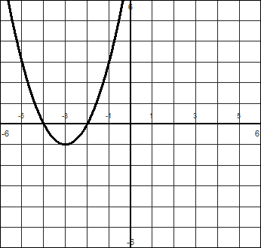 18. 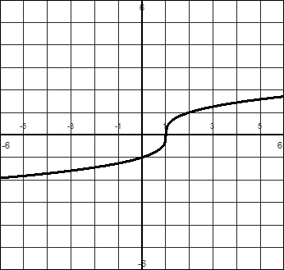

19. 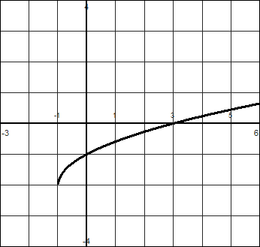 20. 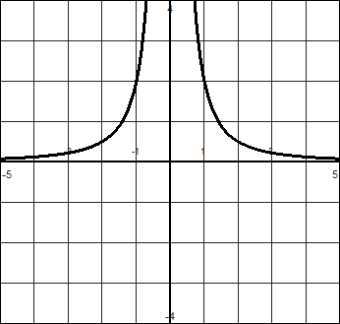

21. 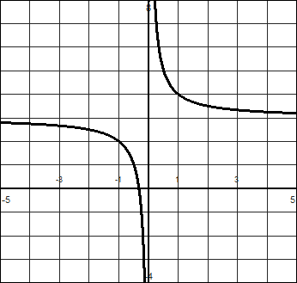 22. 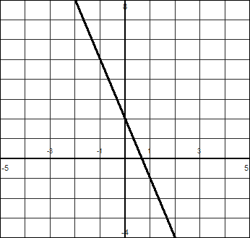

23. 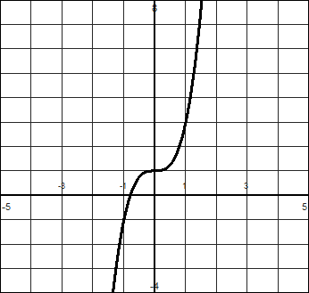 24. 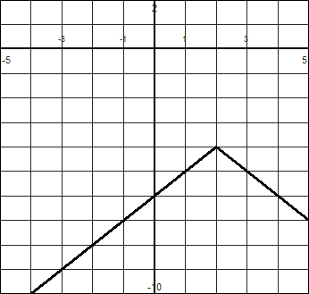

25. shifted up 2, y = f(x) + 2 26. Stretched by 2, y = 2f(x)

27. Reflected and shifted down 1, y = –f(x) – 1

28A. Center (0, 0); radius is 5 B. Center (0, 0); radius is $\sqrt{70}$

29A. Center (3, 0); radius is 6 B. Center (-4, 2); radius is 10

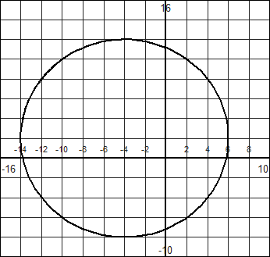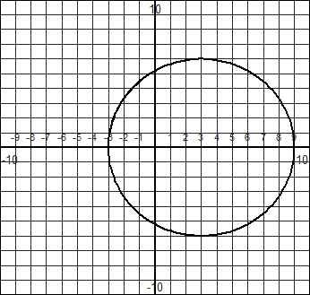

30. (x – 1)2 + (y + 2)2 = 16

31. (x + 3)2 + (y + 1)2 = 4

32. (x – 9)2 + (x – 2)2 = 25

33. (x + 3)2 + (y + 5)2 = 81

**Section 3.4**

1. 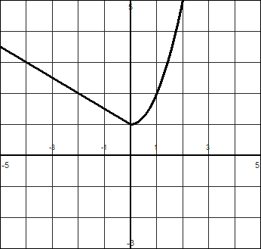 2. 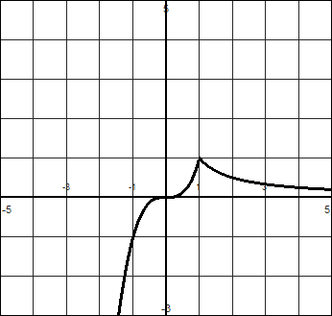

3. 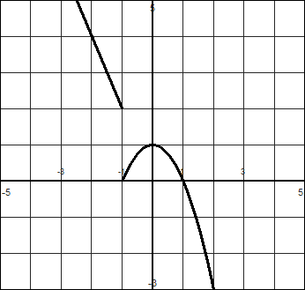 4. 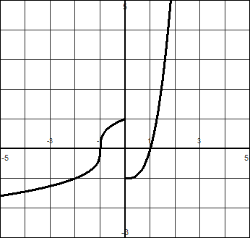

5. 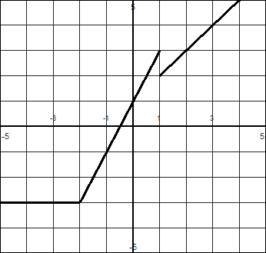 6. 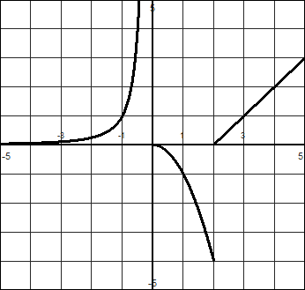

7. 8.

9. 10.

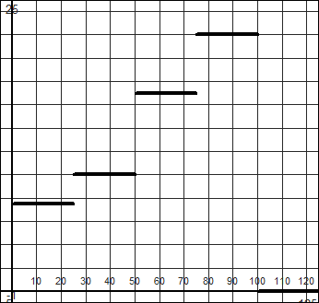11. S(A) =  D=[ 1, ∞); R= {$0, $7.50, $10, $17, $22}

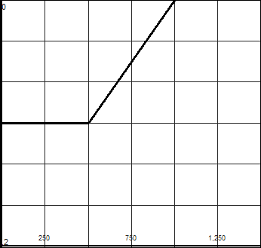12.

**Section 3.5**

1. B 2. A

3. A 4. B

5A. II B. I C. IV D. III

6A. II B. IV C. I D. III

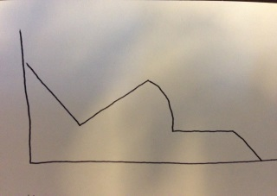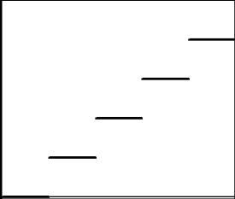

7. 8.

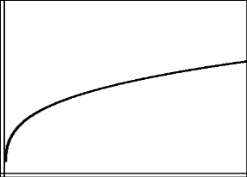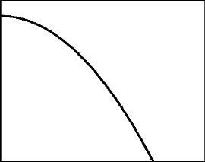9. 10.

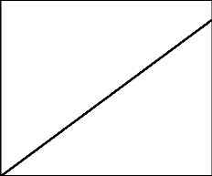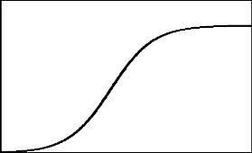11. 12.

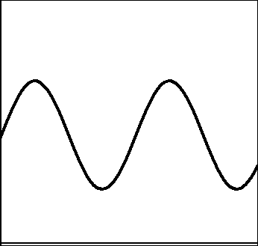

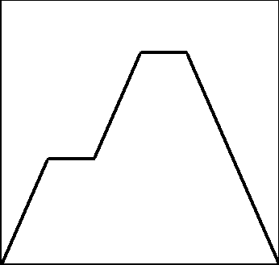13. 14.

15. -3 16. 0.32 17. 32

18. 3 19.  20. 

21. -2.37, the temperature is falling at an average rate of 2.37 degrees Fahrenheit per hour.

22A. 20π sq. inches per inch B. 32π sq. inches per inch

23. -3 feet per second

24A. 2.9667 million/year B. -1.5 million/year C. 1.34 million/year

**Section 3.6**

|  |  |
| --- | --- |
| 1. neither  2. direct  3. inverse  4. direct  5. neither  6. neither  7. inverse; decreasing and undefined when x = 0  8. direct; increasing and includes (0, 0)  9. neither; does not have (0,0) but increasing  10. neither; is not increasing or decreasing  11. y = 150/x2; 37.5; 10  12. y = 3 $\sqrt{x}$; 3; 100/9 or 11 $\frac{1}{9}$ 13. y = 28/x; 14; 11.2  14. y = 3/4x3; 6; 10  15. S = 0.07p; $50000  16. V = 1.75W; 12.25 cups  17. C = 0.058w  **Section 3.7**  1.  Macintosh HD:Users:jphelps:Desktop:Homework 1.png  3.  **Macintosh HD:Users:jphelps:Desktop:homework 3.png** | 18. W = 0.787h3; 199 pounds  19. C = 64s; $232960  20. h = 130/t  21. f = 10/L; f = 1 $\frac{2}{3} or$ 1.67 pounds of pressure  22. v = 9.8t; v = 78.4 m/sec  23. f = 5.625gh3; f = 4860  24. W = 0.225AV; V = 30mph  25. V = HA; V = 153 ft3  26. E = mv2; E = 154.7 ergs  27. ; a = 1296  28. ; V = 138 cm3  29. ; L = 324 metric tons  30. $F=\frac{100rm}{t^{2}}$; F = 43750 dynes  2.  Macintosh HD:Users:jphelps:Desktop:homework 372.png  4.  Macintosh HD:Users:jphelps:Desktop:homework 4.png |
| 5.  Macintosh HD:Users:jphelps:Desktop:homework 5.png  7.  **Macintosh HD:Users:jphelps:Desktop:homework 7.png** | 6.  Macintosh HD:Users:jphelps:Desktop:Homework 6.png  8.  Macintosh HD:Users:jphelps:Desktop:homework 8.png |

**Unit 4**

**Section 4.1**

1. 2.

3. 0.776 4. 6.494

5. yes

6. A. This answer is for the question that is 12:30 PM instead of AM. B. 90.14 miles apart

C. (West 37.5 miles, North 25 miles)

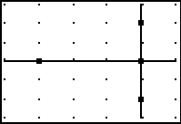

(0, 50)

(-75, 0)

Car A (0, -50)

Car B (0, 0)

7. (4, 3) 8. (-4, 2.5)

9. (1988, 347) In 1988, the average daily jail population was 347 thousand people.

10. (1988, 2617.5) In 1988, the federal deficit was 2617.5 billion dollars.

11. (x – 8)2 + (y + 2)2 = 149 12. (x + 2)2 + (y + 2)2 = 34

**Section 4.2**

|  |  |
| --- | --- |
| 1. x12  2. x-2y11  3. 56  4. m3n3  5. d-2  6. h-10  13. x2y-9  14. 125x-2  15.  16. x4y-6  17. 72d-5  18. 64x6y9 | 7. 2c11  8. u4v  9. w18  10. x20  11. 27y3  12. -8x18y6  19. y  20.  21. $\frac{-3z^{5}}{5}$ 22. $\frac{-8g}{27h^{8}}$ |

**Section 4.3**

|  |  |
| --- | --- |
| 1A. 2 B. 1/5  2A. 1 B. 1/9  3A. 2 B. not real  4A. 1/10 B. 81  5A. h1/3 B. p1/2  6A. m5/4 B. w3  7A. x-1/8 B. x-2/7  8A. B. $\sqrt[7]{x^{4}}$ 9A. $\frac{1}{\sqrt{y}}$ B. $\frac{1}{\sqrt[5]{t^{3}}}$ 10A. B. | 11A. B. 4  12A. x6y-10/3 B. 55/4x-14/3  13A. x6y-2 B. 125c3d-6/5  14A. 8x2y9 B. ½ x-1/6y-4/9  15A. B. ½ x-5/2y1/2  16A. 3cd-3/2 B. 64g2h1/2  17A. x4/3y-1/2 B. $\frac{1}{18x^{11/5}y^{3/2}}$ 18A. 9d-4/5 B. -4x2/3y  19A. $x^{-\frac{7}{6}}y^{-2}$ B. x1/3y19/3 |

**Section 4.4**

|  |  |  |
| --- | --- | --- |
| 1. m4  2. 2y3  3. x2y5  4. 3x3  5. x4  6. y5  7. 2m3  8. x2y  9. 8y9  10. x2  11. 6x2y4  12. 3b  13. 4x3y  14. 2g5h2  15. m3n  16. 2xy  17. g4h | 18. g2h2  19. 6  20.  21. 8  22. 8  23. 3x2  24. 3x2  25. -6  26. 3x3y  27. 0.632  28. 4.0055  29. $\frac{\sqrt{10}}{5}$ 30. $\frac{3\sqrt{7}}{7}$ 31. 2 $\sqrt[3]{2}$ 32. $\frac{\sqrt[3]{75}}{5}$ | |
|  | |  |

33A. B. 32.9mph or 33mph C. 176.04 feet

|  |  |
| --- | --- |
| d | s |
| 23 | 23.5 |
| 50 | 34.6 |
| 75 | 42.4 |

**Section 4.5**

|  |  |
| --- | --- |
| 1. x = 25  2. x = 54  3. x = 33/4  7. x = -69/2  8. x = 8  9. d = 241  10. x = -158  11. No solution  12. b = 261  13. x = 1.732  14. x = $±\sqrt{\frac{46}{5}}$ | 4. No solution  5. x = -8  6. m = -58  15. t = $±\frac{1}{2}$ 16. w = 12-1/3  17. t = 400  18. x = 32/5 = 1.55  19. h = 342, -344  20. d = -11.406  21. x = 126/25 = 5.04  22. No solution |

23A. 122 people B. 24.7 days

24A. 2.84 miles B. 154.14 miles

25A. T = 9.62 sec B. T = 7.45 sec C. L = 7.3 feet

26A. v = 2.21 m/s B. v = 2.89 m/s C. L = 0.74 m

27A. $148 B. $72 C. $50.67 D. 1988 E. 2001

28A. 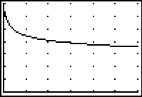 scale=20 B. 87.27 grams C. 18.8 hours D. 58.5 hours

29A. k=202.17 B. H(m) = 202.17m-1/4 C.

100

5000

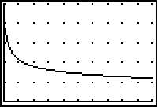

D. 40 bpm E. 68 bpm F. 0.713 kg

|  |  |  |  |
| --- | --- | --- | --- |
| 1 | 2 | 4 | 6 |
| 7.22 | 6.68 | 6.19 | 5.92 |

30A. k = 7.22 B.

31A. k = 0.158; d = 0.158 $\sqrt{t}$ B. 2.12 cm C. 250.36 min or 4.17 hours

**Section 4.6**

1. D 2. C 3. 3 4. 4 5. 2

|  |  |  |  |  |
| --- | --- | --- | --- | --- |
|  | Terms | Coefficient | Degree | Degree of poly |
| 6A. | 2x3, -4x2, 7 | 2, -4, 7 | 3, 2, 0 | 3 |
| B. | 3x3y, 6x2y3, 2x3, 4x2y2 | 3, 6, 2, 4 | 4, 5, 3, 4 | 5 |
| C. | -0.5x3y, 5x2y3 | -0.5, 5 | 4, 5 | 5 |
| D. | 7y, 2 | 7, 2 | 1, 0 | 1 |
| E. | ½ x4y8 | ½ | 12 | 12 |

7A. trinomial B. none C. binomial D. binomial E. monomial

8. binomial, 4

9. monomial, 0

10. 5, 3x5 – 7x4 + 5x3 + 4x2 – 8x + 1

11. -4x5 + 2x4 + 3x3 + 7x2 – 2x + 12

12A. 15x + 5 B. 6x – 18

13A. 4x2 – 14x + 1 B. 4x2 – 5x – 4

14A. 12x2 + 11x + 2 B. 5x2 – 10x

15A. 12x2y + 4xy + 12y2 B. 9x2y + 2y + 3x +4y2

|  |  |
| --- | --- |
| 16. 8x5 + 20x4  17. 20x3 + 5x2 – 40x  18. 6x2 – 11x – 7  19. 2x3 + 8x2 + 4x + 16  20. 10x2 – 3x – 27  21. 6x4 + 13x2 – 5  22. 3x3+ 10x2 + 5x – 4  23. 6x3 + 13x2 – x + 10  24. 10x4 – x3 – 19x2 + 14x – 8  25. 18x2 – 9xy + 2y2  26. x + 4 + 2x-1  27. 2 + 10x-1 + 5x-2  28. 2x2 + 20/3 x + 4  29. ½ x + 10 + 6x-1 – ½ x-2  30. x + 4 -  31. 3x + 8 + | 32. 4x – 14 +  33. 6x + 13 +  34. x2 – 4x + 2 +  35. x + 3 -  36. x2 – 2x + 3 +  37. 5x – 17 +  38. 3x + 7 +  38. 2x2 – 2x – 5 +  39. -19  40. -7  41. -144  42. 35 |

**Section 4.7**

|  |  |
| --- | --- |
| 1. 9i  2. 3i  3. -20  4. 18i  5. -5 -5i  6. 7 – 8i  7. -5 + 6i  8. 4 – 2i  9. 26 – 7i  10. 53 + 5i  11. -11 + 78i  12. -3 – 28i | 13. 10 + 40i  14. -10 + 8i  15. 34  16. 53  17. -3 – 3i  18. -16/25 + 37/25 i  19. -17/10 + 9/10 i  20. 23/29 – 14/29 i  21. –*i*  22. *i*  23. -1  24. 1 |

**Unit 5**

**Section 5.1**

|  |  |
| --- | --- |
| x | F-1(x) |
| 2 | -1 |
| 5 | 0 |
| -3 | 1 |
| 7 | 2 |
| 1 | 3 |

|  |  |
| --- | --- |
| x | F-1(x) |
| 0 | 2 |
| -1 | 4 |
| -2 | 7 |
| 0 | 9 |
| -1 | 12 |

1. 2.

Yes, the inverse is a function No, the inverse is not a function

|  |  |
| --- | --- |
| Height | Time |
| 3 | 1 |
| 51 | 2 |
| 67 | 3 |
| 51 | 4 |

|  |  |
| --- | --- |
| t | g-1(t) |
| 11 | -1 |
| -7 | 3 |
| 1 | 5 |
| 5 | 8 |
| -1 | 10 |

3. 4. g-1(5) = 8

No, the inverse is not a function

|  |  |  |  |  |
| --- | --- | --- | --- | --- |
| d | 0.5 | 0.87 | 1.01 | 1.24 |
| t | 10 | 30 | 40 | 60 |

5.

6A. f-1(5) = -3; f-1(0) = 2; f-1(4) = 0, f-1(7) = 2 B. f-1(0) = -2 C. f-1(7) = 2

7. f-1(x) =

8. g-1(x) =

9. f-1(x) =

10. h-1(t) =

11. g-1(m) = 8m + 3

12. f-1(d) =

13. h-1(x) =

14. Y-1(x)

15A. C(75) = 23.9; A temperature of 75°F is about 24°C.

B. 82.4° C. F(C) = 9/5 C + 32 D. C-1(28) = 82.4°

16A. W(40) ≈ 83 After 40 hours, the bat weighs about 83 grams.

B. W-1(80) = 46 Bat weighs 80 grams about 46 hours after its last meal.

|  |  |
| --- | --- |
| d | s |
| 20 | 22 |
| 35 | 29 |
| 80 | 44 |

|  |  |
| --- | --- |
| s | d |
| 22 | 20 |
| 29 | 35 |
| 44 | 80 |

17A. B.

C. s-1(d) = d2/24 D. s-1(70) = 204; At 70mph, the stopping distance is 204 feet.

E. s(70) = 41; At a stopping distance of 70 feet, the car was traveling at 41 mph.

18. 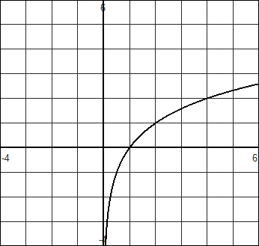 yes 19. 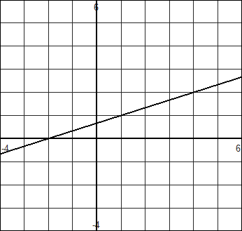 yes

20. 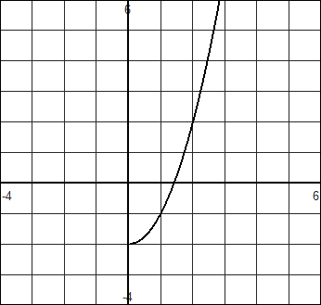 yes 21. 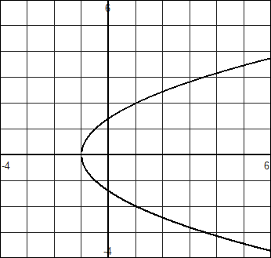 no

22. 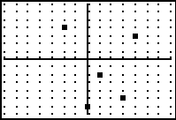 yes 23. 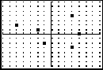 no

24. 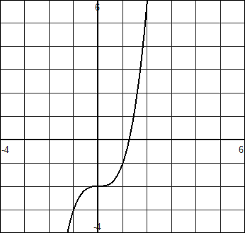 yes 25. 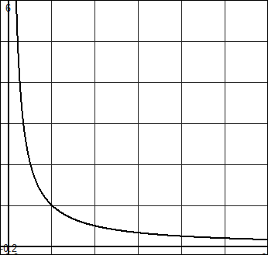 yes

26. 18, 19, 20, 22, 24, 25 27. =x;

28. =x; 29. =x;

30. Domain: $\left[0, ∞)\right.$ 31. Domain: $[-1,∞)$

**Section 5.2**

|  |  |  |  |  |
| --- | --- | --- | --- | --- |
| **0** | **1** | **2** | **3** | **4** |
| **20** | **60** | **180** | **540** | **1620** |

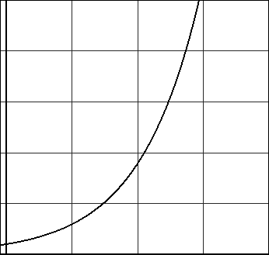1A. B. P(t) = 20(3)t C.

D. P(1.5) = 103.92 E. 20(3)t = 1000; t = 3.561

|  |  |  |  |  |
| --- | --- | --- | --- | --- |
| 0 | 5 | 10 | 15 | 20 |
| 35 | 140 | 560 | 2240 | 8960 |

2A. B. P(t) = 35(4)t/5 C. P(3) = 80.41

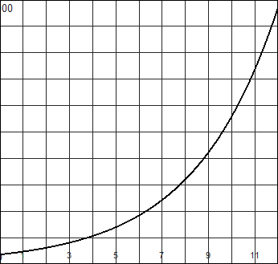D. E. t = 3.786

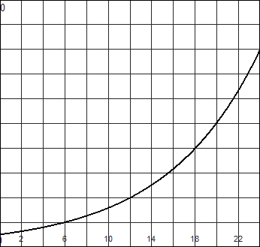3A. B.

|  |  |  |  |  |
| --- | --- | --- | --- | --- |
| 0 | 6 | 12 | 18 | 24 |
| 1 | 2 | 4 | 8 | 16 |

C. P(t) = 1(2)t/6 D. P(8) = 2.52

E. P(48) = 256

4A. P(t) = 1(2)t/5 B. P(86) = 150562.19

5A. T(t) = 125.91(1.14)t B. T(5) = $242.43 C. t = 6.626 years

6A. P(t) = 1001t/25 B. P(31) = 5254.6

7A. P(t) = 285(1.75)t B. P(9) = 43871.99

8A. P(t) = 5078(2)t/5 B. P(13) = 30787.23

9A. P(t) = 2.79(1.08)t/6 B. P(15) = $3.38; P(24) = $3.80

10A. P(t) = 40000(1.05)t B. P(30) = $172877.70

11. A(t) = 7000(1.039)t; A(3) = 7851.36; A(10) = 10262.51

12A. A(t) = 350 ${\left(1+\frac{.025}{2}\right)}^{2t}$ B. A(5) = 396.29

13. A(t) = 2000 ${\left(1+\frac{.06}{365}\right)}^{365t}$; A(1) = 2123.66; A(4) = 2542.45

|  |  |  |  |  |
| --- | --- | --- | --- | --- |
| 0 | 1 | 2 | 3 | 4 |
| 25000 | 21250 | 18062.50 | 15353.13 | 13050.16 |

14A. B. V(t) = 25000(0.85)t

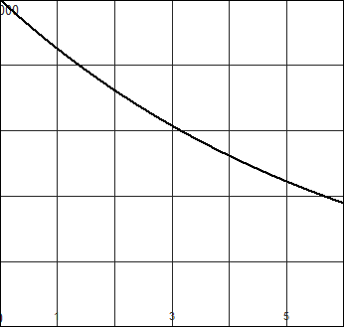 C. D. V(3.5) = 14154.88 E. t = 4.265

15. P(t) = 150(1/2)t/15

16. P(t) = (1/2)t/5730; t = 9952.8

17A. P(t) = 70(1/2)t/200 B. t = 444.478

18. P(t) = (½ )t/7; P(40) = 0.019

19A. P(t) = 500(2/3)t/2 B. P(4) = 222.22 C. t = 12.458

**Section 5.3**

1. 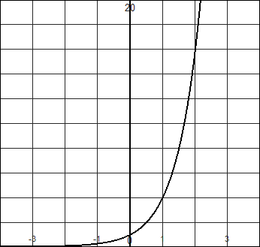 2. 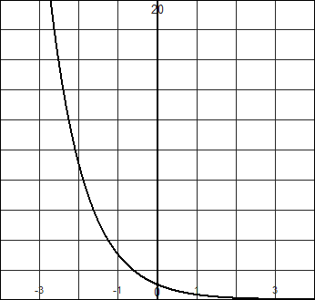 3. 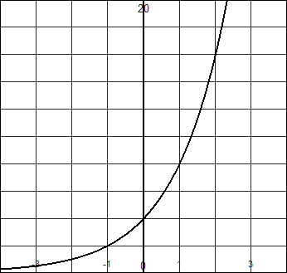

4. 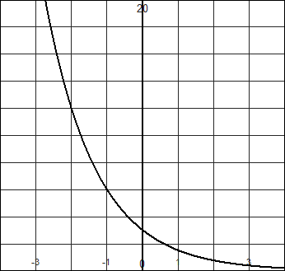 5. 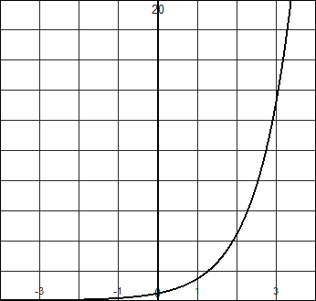 6. 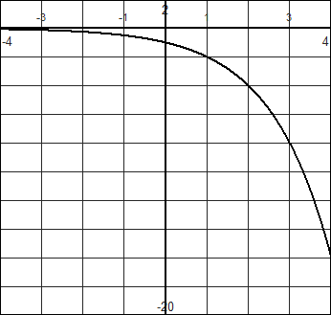

7. 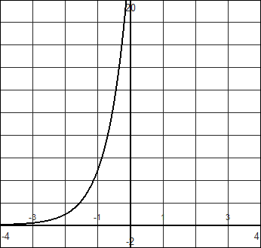 8. 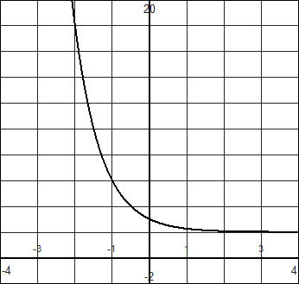 9. 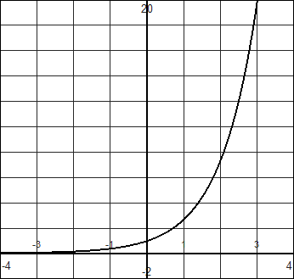

10. 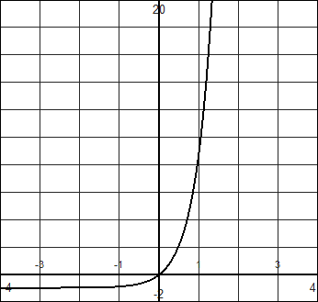

11A. f(x) = 2x + 3 B. f(x) = 3(2)x C. f(x) = -2x + 1 D. f(x) = 4(2)x

|  |  |
| --- | --- |
| 12. (0, 6.2) decreasing  13. (0, 2) increasing  14. (0, 2/3) increasing  15. (0, 5/2) decreasing  16. g(x) = 3(2.5)x  17. f(x) = 32(1/2)x | 18. f(x) = 40(3/4)x/4  19. g(x) = 100(5)x/10  20. f(x) = 3(1/4)x  21. f(x) = 4(1/2)x  22. f(x) = ½ (6)x  23. f(x) = 2(5)x/2 |

24a. f(4) = 1296 b. f(3) – f(1) =210 c. f(a+h) = $6^{a+h}$ d. $\frac{f\left(a+h\right)-f(a)}{h}=\frac{6^{a+h}-6^{a}}{h}$

25a. f(2) = 65 b. 3f(2) = 195 c. f(a+h) = d.

26. Neither

**Section 5.4**

|  |  |
| --- | --- |
| 1. log4(16) = 2  2. log5(125) = 3  3. log7(1) = 0  4. log2(1/2) = -1 | 5. log36(6) = ½  6. logH­(d) = 4  7. logx(z) = y  8. logm(3) = 7 |
| 9. 25 = 32  10. 51 = 5  11. b3 = m  12. p2 = 30  13. 10n = t  14. ev = 9  15. 6-4 = 6-4  16. 1001/2 = 10  17. 1.279  18. 2.477  19. 3.807  20. 4.718  21. 3  22. 2  23. 3  24. ½  25. 8  26. 7 | 27. 0  28. 4  29. 1  30. 1/3  31. $\frac{log⁡(22)}{log⁡(4)}$ = 2.23  32. $\frac{log⁡(121)}{log⁡(6)}$ = 2.677  33. $\frac{ln⁡(400)}{ln⁡(12)}$ = 2.411  34. $\frac{ln⁡(18)}{ln⁡(3)}$ = 2.631  35. $\frac{log⁡(37)}{log⁡(b)}$ 36. $\frac{ln⁡(g)}{ln⁡(f)}$ 37. 2.64  38. 2.367  39. 1.892  40. 4.357 |

**Section 5.5**

|  |  |
| --- | --- |
| 1. x = 13/3  2. x = 7  3. x = 4  4. x = 1  5. x = 17/3  6. x = 4  7. x = 3  8. x = -5  9. x = 1.277  10. x = 4.358  11. x = 1.807  12. x = 0.389  13. x = -6.276  14. x = -1.903 | 15. x = 1.544  16. x = -3.145  17. x = -0.528  18. x = 15.275  19. x = 0.999  20. x = 30.543  21. 2t/5 = 1000; t = 49.829 minutes  22. t = 7.8 or 2015  23. t = 29.379 months  24. t = 9.056 years  25. t = 18.12 years; t = 28.715 years  26. t = 3.802 years; t = 11.405 years  27. t = 13.887 years  28. t = 28.61 hours |

**Section 5.6**

|  |  |
| --- | --- |
| 1. 7  2. 9  3. -2  4. 11  5. t  6. 1/3 | 7. 12  8. 2  9. 6  10. x  11. 13  12. n |

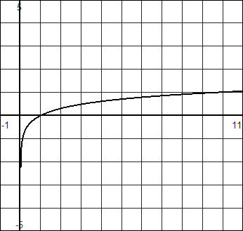13. 14.

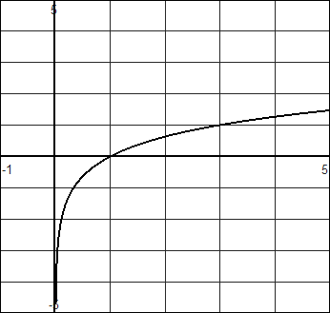

15. 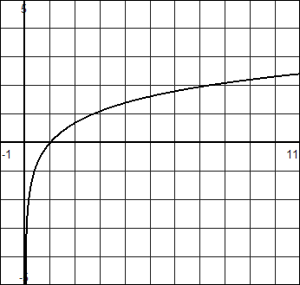 16. 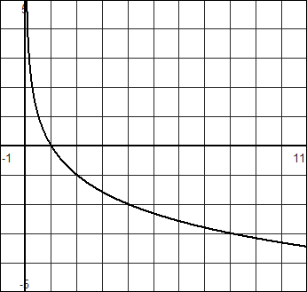

|  |  |
| --- | --- |
| 17. log3(7) + 6log3(x)  18. 2loga(x) + 3loga(y)  19. 2[ln(m) + ln(n)]  20. 4logb(x+3) + 5logb(y+6)  21. ½ log6(3) + ½ log6(x) – log6(y)  22. log2(4) + log2(t) – log2(r)  23. 1/3 (ln(x) – ln(y))  24. log(g) – 5 log(h)  25. $\log_{b}\left(\frac{z}{w}\right)$ 26.  27. log4(x2w3) | 28.  29.  30. $\log_{b}\left(\frac{x^{3}y}{\sqrt[4]{z}}\right)$ 31. x = 2/15  32. x = 501/98  33. x = 1  34. x = 50/7  35.A. f(65) = 71.03 B. 1947 C. 75.3  36.A. 20.6 decibels B. 89.5 decibels  37.A. 79.82% B. 73.9 inches  38. $(f°f^{-1})(x)$ =x; $\left(f^{-1} °f\right)\left(x\right)=x$ |

**Section 5.7**

|  |  |
| --- | --- |
| 1A. 1050.63 B. 1218.40 C. 22.246  2A. 5254.73 B. 5256.36  3. 35526.77  4. 3194.11  5. 8.85%; 8.66%  6. 8.15%; 7.83% | 7. P = 63940(1.051)t  8. C = 0.97(1.0528)t  9. $1276.92  10. A = 125(0.7)t  11a. T = 150(1.17)t b. 150 c. 721 turtles  12. V = 33430(0.88)t |

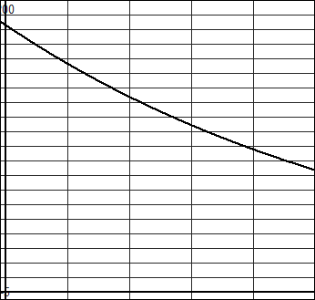13A. T = 182.4(0.9845)t B.

C. 182.4°

D. 35 minutes

E. 10 minutes

14. (5, 4000), (8, 24000) ; f(x) = 202(6)x/3 or f(x) = 202(1.817)x

15. (5, 30), (7, 130); f(t) = 0.767(2.082)t

**Section 6.1**

|  |  |
| --- | --- |
| 1. 7x(x – 3)  2. 3x(2x2 – 4x + 5)  3. 4x2 (2x + 1)  4. (t + 9)(t – 9)  5. (y + 3)(y2 – 3y + 9)  6. (4h-1)(16h2 + 4h + 1)  7. 3(x + 3)(x – 3)  8. (2d + 5)(2d – 5)  9. (x + 2)(x + 4)  10. x(x + 3)  11. (x + 3)(x – 2)  12. (x – 4)(x + 3)  13. (x + 4)(x + 2)  14. (x + 7)(x + 8)  15. (x – 1)(x – 3)  16. (x – 3)(x + 1)  17. (x + 4)(x – 4)  18. (x + 8)(x + 10)  19. (x – 6)(x – 1)  20. (x + 9)(x + 8)  21. x(x – 9)  22. (x + 6)(x + 2)  23. -7(5x – 9)  24. –(4x – 7)(x – 9)  25. -2(5x – 2)(6x – 1)  26. (x – 2)(4x – 7)  27. (3x + 1)(x + 2)  28. (x + 7)(x – 7)  29. x2 + 49 or unfactorable  30. 3x2(x2 + 3) | 31. x2 + 2x – 6 or unfactorable  32. (x – 24)(x + 3)  33. 4(x + 1)2  34. or unfactorable  35. (x2 - 9)(x2 – 1) = (x + 3)(x – 3)(x + 1)(x -1)  36. (3x - 2)(11x + 7)  37. (4x + 5)(x2 + 7)  38. (x2 + 7)(x + 2)  39. (3x2 + 7)(x – 2)  40. 2(x – 1)(3x2 – 5)  41. 5(2x + 1)(x + 3)  42. (3x – 1)(2x + 1)  43. (t – 2)(4t + 3)  44. (3y + 1)(y + 4)  45. (2m – 3)(4m + 1)  46. (4k – 5)(2k + 3)  47. (3a + 7)(a + 1)  48. (2a – 5)(a – 6)  49. (4x – 1)(2x – 3)  50. 2 (r + 1)(7r + 1)  51. (a – 2)(5a + 3)  52. (3p – 2)(5p + 3)  53. (4r – 3)(r + 1)  54. (4s + 5)(3s – 1)  55. (2q + 3)(3q + 7)  56. 3(p + 2)(3p – 4)  57. (3r – 5)(r + 2)  58. (3x + 4)(2x – 3)  59. (5x + 2y)(25x2 – 10xy + 4y2)  60. 5(n – 2)(n2 + 2n + 4) |
|  |  |

**Section 6.2**

|  |  |
| --- | --- |
| 1. x = -1.6, x = 2.2  2. x = 1.8, x = -5.8  3. x = 2.61, x = -1.277  4. x = 22.808, x = 2.192  5. x = 1.338, x = -4.671  6. x = 1.766, x = -2.266  7. x = -5, x = -4  8. x = -2, x = 1  9. x = -6, x = 2  10. x = 3, x = -3  11. x = $±\sqrt{2}$ 12. x = $±\frac{\sqrt{14}}{2}$ 13. x = 1, x = -3  14. x = $\frac{±\sqrt{10}+1}{3}$ 15. x = 5/2, x = -1/3  16. x = 5, x = -1/3  17. x = 5, x = 7  18. x = -2/3, x = -7  19. x = 8 ± 2 $\sqrt{26}$ 20. x = $\frac{-5±\sqrt{35}i}{2}$ | 21. $x=\frac{-6±\sqrt{23}}{2}$ 22. x = x = 5/2, x = -1/3  23. x = $\frac{1±\sqrt{13}}{4}$ 24. x = $\frac{-5±\sqrt{31}i}{4}$ 25. x = $\frac{-7±\sqrt{157}}{6}$ 26. x = $\frac{-9±5\sqrt{5}}{2}$ 27. x = $\frac{-1±\sqrt{2}}{2}$ 28. x = $±\sqrt{\frac{17}{3}}$ 29. x = 1, x = 7  30. x = ½ ± $\frac{\sqrt{15}}{6}i$ 31. x = ± 3/2  32. x = $\frac{9±\sqrt{21}}{10}$ 33. x = ±2, x = $±\sqrt{\frac{1}{2}}$ 34. x = $±\sqrt{\frac{-1±\sqrt{61}}{6}}$ 35. x = ¼, x = 9  36. x = ${\left(\frac{5±\sqrt{33}}{2}\right)}^{2}$ |

**Section 6.3**

|  |
| --- |
| 1. (0, -25), (5, 0), (-5, 0)  2. (0, 28) (-7, 0)(-4 , 0)  3. (0, -3), (1, 0), (-3/2, 0)  4. (0, 5), (5/2, 0), (1, 0)  5. (0, 20), (5/3, 0), (1, 0)  6. (0, 40), (-2, 0), (-10, 0)  7. (0, 3)  8. (0, 1), ( $\frac{7±\sqrt{41}}{4}, 0)$ 9. (0, -11)  10. (0, 22)  11. (-7, -2); x = -7  12. (-5, 3); x = -5  13. (3, -1); x = 3  14. (-1, -9); x = -1  15. (-6, -2); (0, -74); no x-intercepts  16. (-2, -9); (0, 3); (-2 ± $\sqrt{3}, 0)$ 17. (3, -4); (0, -1); (3 ± $\sqrt{12}, 0)$ 18. (-5, -8); (0, -33); no x-intercepts  19.  (-5, 2); (0, 27);no x-intercepts  20.  (7, -8); (0, 90);(5, 0), (9,0)  21.  (1, -5); (0, -11/2); no x-intercepts  22.  (-3, -9); (0, -18);no x-intercepts  23. a > 0, b ≠ 0, c < 0  24. a < 0, b ≠ 0, c > 0  25. a > 0, b ≠ 0, c = 0  26. a < 0, b = 0, c < 0  27. Concave down, (0, 11), vertex off y-axis  28. concave up, (0, 1), vertex on y-axis  29. concave up, (0, -5), vertex off y-axis  30. concave down, (0, 3), vertex off y-axis  31. vertex (0, -5) intercepts (0, -5), (± $\frac{\sqrt{5}}{2},0)$ 32. vertex (-1/12, -121/24), intercepts (0, -5), (5/6, 0), (-1, 0)  33. vertex (-3, -3) intercepts (0, 0), (-6, 0)  34. vertex (2, 7) intercepts (0, 3), ( $\frac{4±\sqrt{28}}{2},0)$ 35.a. (0, 4) b. (4, 0) (-1, 0) c. (3/2, 25/4) d. down e. standard f.  36.a. (0, 4) b. $\left(\frac{4±\sqrt{8}}{2},0\right)$ c. (2, -4) d. up e. stretched f.  37.a. (0, -1) b. (-3 $±\sqrt{11}, 0)$ c. (-3, -11/2) d. up e. shrunk f.  38. f(x) = (x + 6)2 – 31  39. f(x) = (x + 7/2)2 – 89/4  40. f(x) = 3(x – 2)2 + 5  41. f(x) = 2(x + 5)2 – 61 |

**Section 6.4**

1. y = x2 + 2x – 15; y = 2(x2 + 2x – 15)

2. y = x2 – 7x + 12; y = 6(x2 – 7x + 12)

3. y = -(x2 + 3x – 4); y = -3(x2 + 3x – 4)

4. y = -(x2  - 2x – 24); y = -1/2 (x2 – 2x – 24)

5. y = -1/8 (x2 + 3x – 28)

6. y = 3/10 (x2 + 7x + 10)

7. y = 2/21 (x2 – x – 42)

8. y = 5/49 (2x2 + 5x – 3)

9. y = -2/5 (x2 – 2x – 24)

10. y = 2(x + 2)(x – 3)

11. y = ½ (x2 – 4x + 3)

12. y = -(x2 + 5x + 4)

13. y = -2(x – 3)2 + 1

14. y = 1.5(x + 2)2 – 3

15. y = (x – 4)2 + 2

16. y = - ½ (x + 2)2 + 5

17. y = ¼ (x + 4)(x – 5)

18. y = 1/3 (x + 1)2 – 2

19. y = 16/3 (x – ½)2 – 5

20. y = -3/16 (x + 3)2 – 5

21. y = 2/3x2 – 16/3 x + 10

22. y = -0.4x2 + 0.8x + 3.2

23. y = 2x2 – x + 4

24. y = 2/3x2 + 5/3x + 1

25. y = -3/2x2 + ½ x + 2

26. using first 3 points y = -16x2 + 1821

27. using first 3 points (with a and c approximated) y = 131.67

28. using first 3 points C = 0.0035v2 – 0.295v + 12.2

29. h = -23/15000 (x – 150)2 + 38

30. h = -4.9(t – 1.5)2 + 11.025

31. h = -0.006(x – 1)2 + 11.5

**Section 6.5**

|  |  |
| --- | --- |
| 1. increasing (-∞, 7);decreasing (7, ∞); maximum = 5  2. decreasing (-∞, -11);increasing (-11, ∞); minimum = -8  3. decreasing (-∞, 5/6);increasing (5/6, ∞); minimum = 95/12  4. increasing (-∞, -7/4);decreasing (-7/4, ∞); maximum = 57/8  5. L = 7.31 ft; W = 12.31 ft  6. 7.204 hours  7A. 4.146 sec B. Never C. (0, 4.146)  8A. 2.993 sec B. 3.189 sec C. (0, 1.53) D. 1.53 sec, 13.48m  9. T = 1/2°C  10. t = 4.33 sec  11. t = 4.9 seconds to hit the ground; maximum height of 186 ft after 1.5 sec  12A. minimum area = 0 B. 3 x 9 meters  13. W = 50/3 yds; L = 25 yds  14A. 85.73 ft B. 0.857 inch  15A. H(50) = 125.319 horsepower B. 63.18 mph  16A. 500 tennis balls, -$2300 B. less than 500  17. 1100 units  18. 40 items |  |

19. 2.367 sec

20. 72 ft x 160 ft

21. x = 3 ft; y = 14 ft

22. W = 20; L = 30 yds

23. Base = 8 ft; Height = 5 ft

24. 6 ft by 15 ft

25A. 50 by 200 or 100 by 100 B. 11250 ft2 (75 by 150 ft)

26A. Not possible B. 31250 ft2 (125 by 250 ft)

**Section 6.6**

1a. Between 0 and 2.165 seconds b. Between 3.317 and 4.146 seconds

2a. Between 3.028 and 3.189 seconds b. Between .473 and 2.588 seconds

3. Between -2 and 4.89 degrees Celsius

4. Between .946 and 3.304 seconds

5. The diameter needs to be between 6.187 and 6.654 inches.

6. Less than 1009.9 tennis balls

7. Between 20 and 67 items

8. He is between 7.74 and 8.61 feet from the diving board. He enters the water at 8.61 feet.

9. As long as the width is less than 50 feet (with the corresponding length = 300 – 2w) and the length is greater than 100 feet (with the corresponding length = 300 – 2w).

**Section 7.1**

|  |  |
| --- | --- |
| 1. $\frac{4}{x+7}$ 2. $\frac{x-7}{x-8}$ 3. 4x  4. $\frac{5}{3(x-4)}$ 5. $\frac{x-7}{3(x+4)}$ 6. $\frac{x^{3}y}{2}$ 7. $\frac{5}{6d^{2}}$ | 8. $\frac{1}{2g}$ 9. $\frac{(h+1)(h+2)}{3h(h-1)}$ 10. $\frac{10{\left(j-1\right)}^{n-2}}{j}$ 11. $\frac{(t+3)(t-3)}{t(t-9)}$ 12. $\frac{v-1}{4(v+1)}$ 13. $\frac{5}{6}$ 14. $\frac{x(x+1)}{4}$ |
| 15. $\frac{y+1}{y-3)(y+5)}$ 16. $\frac{5(x-1)}{2(2x+1)}$ 17. 21/2  18. 1/9  19. $\frac{a-7}{a+3}$ 20. $\frac{(3x+5)(x+1)}{4}$ 21. $\frac{-14}{m-4}$ 22. $\frac{15p+4}{p-1}$ 23. $\frac{5x+10}{x+2}=5$ 24. $\frac{-t-2}{t}$ 25. $\frac{x-3y}{xy}$ 26. $\frac{15p-11}{p(p-1)}$ | 27. $\frac{2a^{2}-4a+9}{6a}$ 28. $\frac{-4m+31}{(m-4)(m+1)}$ 29. $\frac{-tx-3ty}{(x-y)(x+y)}$ 30. $\frac{2c+4d}{c^{2}d}$ 31. $\frac{-m+1}{(m-2)(m+3)}$ 32. $\frac{21g+1}{2g(3g-2)}$ 33. $\frac{2x^{2}+xy+y^{2}}{{\left(x+y\right)}^{2}(x-y)}$ 34. $\frac{2x^{2}-x+5}{(x+3)(x-3)(x+1)}$ 35. $\frac{-3y-7}{(y+3)(y+4)}$ 36. $\frac{-13}{15(t-5)}$ |

**Section 7.2**

|  |  |
| --- | --- |
| 1A. x= 5 B. x = 1  2A. x = -3 B. x = 1 C. x = -1.5  3. x = 1.1  4. x = -1.636  5. x = -13/5  6. c = -11/8  7. x = 6, x = -2  8. No solution  9. x = -16  10. x = 39/7  11. t = 2.57  12. x = 3.73  13. $\frac{12}{8}=\frac{20}{x}$; x = 13.3 days  14. $\frac{6}{4}=\frac{15}{x}$; x = 10 days  15. $\frac{15}{3}=\frac{L}{4}$; L = 20 liters  16. $\frac{2.5}{7}=\frac{98.6-65}{s}$; s = 94 seconds  17. $\frac{17}{2}=\frac{P}{5}$; P = 42.5 hours  18. $\frac{80}{1}=\frac{w}{30}$; w = 2400 words  19. $\frac{8.7}{1000}=\frac{D}{28142/906}$; D = 2,448,371 deaths  20. $\frac{15}{400}=\frac{D}{1000};$ D = 37.5 or 38 parts  21. $\frac{18}{12}=\frac{I}{1}$; I = 1.5 inches | 22. $\frac{22}{30}=\frac{100}{m}$; m = 2 hours 16 minutes  23. $\frac{1}{8}=\frac{w}{32}$; w = 4 women  24. $\frac{280}{D}=\frac{45}{405}$; D = 2520 total deer  25. $\frac{5}{2.99}=\frac{P}{8.50}$; P = 14.2 pounds  26. $\frac{3+x}{5+x}=\frac{7}{9}$; x = 4  27. $\frac{1}{6}+\frac{1}{4}=\frac{1}{T}$; T = 2.4 hours  28. $\frac{1}{8}-\frac{1}{10}=\frac{1}{T}$; T = 40 hours  29. $\frac{1}{S}+\frac{1}{16}=\frac{1}{9}$; S = 20.57 hours  30. $\frac{1}{P}+\frac{1}{P+3}=\frac{1}{2}$; P = 3 hours  31. $\frac{1}{12}+\frac{1}{15}=\frac{1}{T}$; T = 6.67 hours  32. $\frac{1}{1}-\frac{1}{2}=\frac{1}{T}$; T = 2 minutes  33. $\frac{1}{6.5}-\frac{1}{8.25}=\frac{1}{T}$; T = 30.64 minutes  34. $\frac{1}{5}-\frac{1}{4}=\frac{1}{T}$; No the water is draining faster than it is being filled.  35. $\frac{1}{6}+\frac{1}{5}=\frac{1}{T}$; T = 2.727 hours  36. $\frac{1}{2}+\frac{1}{2.5}=\frac{1}{T}$; T = 1.11 hours  37. 16.67 miles  38. $\frac{250}{R}=\frac{420}{R+30}$; 44km/h (Jody) 74 km/h (James)  39. $\frac{440}{R-16}=\frac{600}{R}$; R = 60 km/h (empty) 44 km/h (loaded) |

**Section 7.3**

1A. x = 0, x = ½ B. y = 0 C. (-4, 0) D. 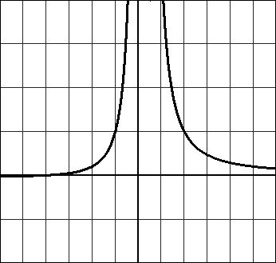

2A. x = -1/2, x = 1 B. y = 2 C. (0, -4) D. 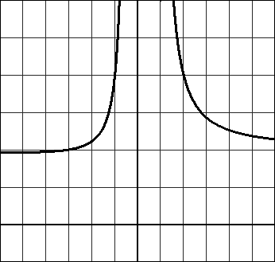

3A. x = 4, x = -4(hole) B. y = 0 C. (0, -1/4) D. 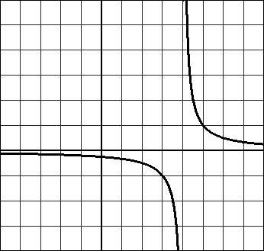

4A. x = -1, x = 2 B. y = 0 C. (0, 5/2), (5, 0) D. 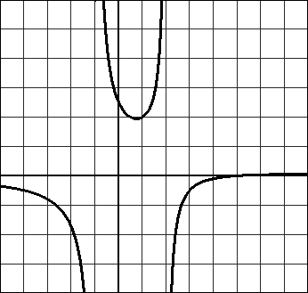

5A. x = 3 B. y = x + 3 C. (0, 4/3) D. 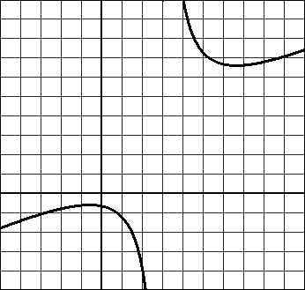

6A. x = 1, x = 2 B. y = 0 C. (0, -3) D. 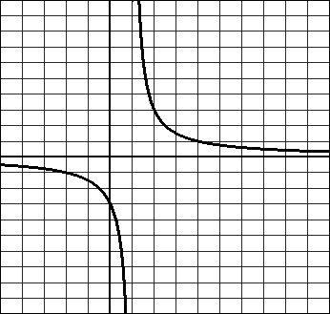

7A. x = -2 B. y = 1 C. (0, 2)(-4, 0) D. 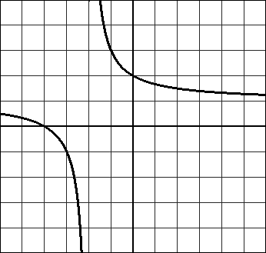

8A. x = 3 B. y = 1/3x + 1 C. (1,0), (-1, 0), (0, 1/9) D. 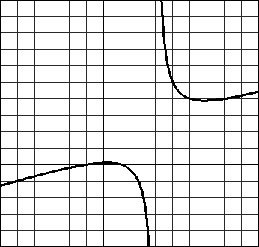

9A. C = 750 + 92(15) = 2130 annual cost = $142/year B. AC = $\frac{750+92x}{x}$

C. 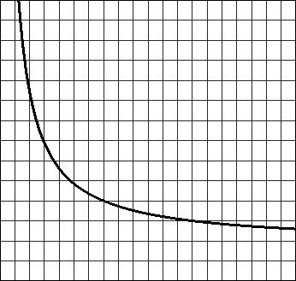 D. x = 0, y = 92

E. The annual cost approaches $92/year as time increases. F. AC = $152/year; No

10A. AC = $141.22 per year B. AC = $\frac{560+79x}{x}$ C. 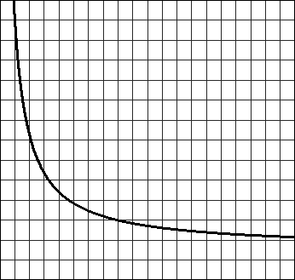

D. y = 79, x = 0 E. The annual cost approaches $79 per year as time increases.

11A. 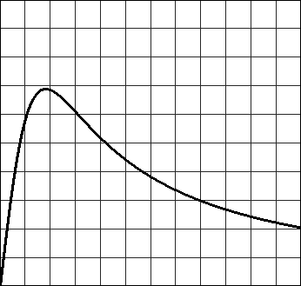 B. At 18 minutes, 13.76 mc/mL

C. Concentration increases for the first 18 minutes, then decreases rapidly at first then more slowly.

D. y = 0, The concentration approaches 0mc/mL as time passes.

12A. (30, 3.33), (55, 1.818), (65, 1.538) B. T = 100/s

C. 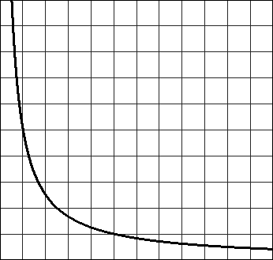 D. As the speed increases, the time decreases.

13A. C = $\frac{80+6s}{s}$ B. 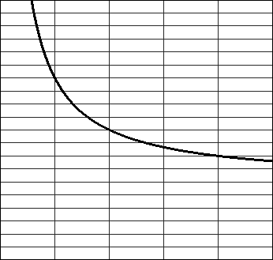

14A. [0, 100) B. $117, 857;$275000 C. 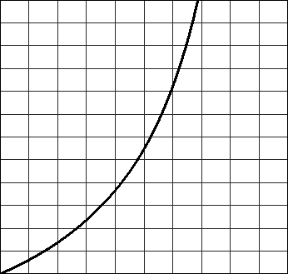

D. 64.5% E. P = 100 It is impossible to remove 100% of the ore.

15A. A = $\frac{25000+15n}{n}$ B. 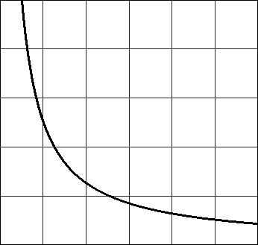 C. 3571 calculators

D. A =15 Average cost approaches $15 per calculator as the number of calculators produced increases.

**Section 7.4**

|  |  |
| --- | --- |
| 1. D = 5; LC = -11  2. D = 6; LC = 9  3. D = 4; LC = -8  4. D = 6; LC = -11  5. D = 4; LC = -2  6. D = 7; LC = 1  7. ↑↓  8. ↑↑ | 9. ↓↓  10. ↓↓  11. ↓↓  12. ↓↑  13. (0, -5), (4, 0), (8,0)  14. (0, 0), (3, 0), (5, 0)  15. (-1, 0), (2, 0), (5, 0) |

16. 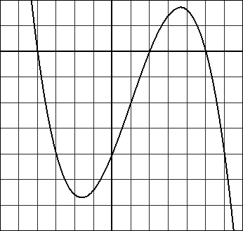 17. 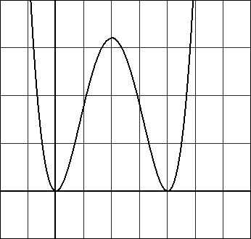 18. 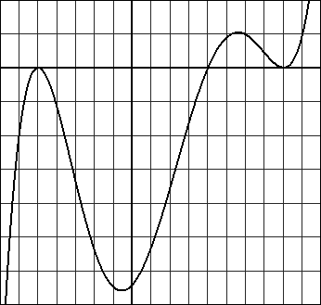

19. 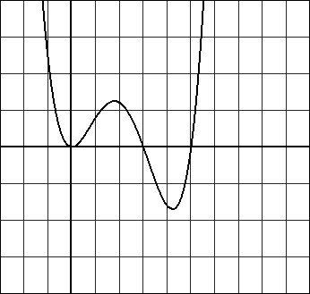 20. 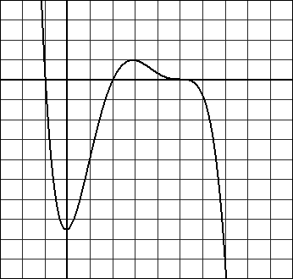 21. 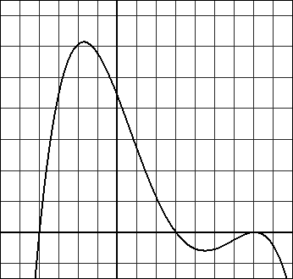

22. 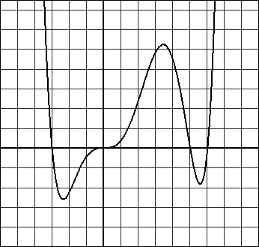

23. y = (x+2)2(x – 4)

24. y = -x(x+3)(x – 4)2

25. y = -x(x + 3)(x + 1)(x – 3)

26. y = x(x + 2)(x + 1)(x – 3)

27. y = x(x + 3)(x + 1)2

28. y = -(x + 3)(x + 1)3 (x – 1)

29. (x-3)(x-2)(x-1)2(x+3)

30. (x-5)(x-3)(x-2)(x+3)

31. (x-5)(x-2)(x+4)

32. (x-5)(x-2)(x+2)2

33. (x+1)(2x+5)(3x-2) or 6(x+1)(x+5/2)(x-2/3)

**Section 7.5**

1A. x = -4 B. (-4, 0) C. (-∞, -4) U (0, ∞)

2A. no solution B. (-∞, 1) C. (1, ∞)

3A. x = -1 B. (-∞, -2) U (-1, 1) C. (-2, -1) U (1, ∞)

4A. x = -3, x=1, x=2 B. (-∞, -3) U (1, 2) C. (-3, 1) U (2, ∞)

5A. x = -2, x=0, x=1, x=3 B. (-2, 0) U (1, 3) C. (-∞, -2) U (0, 1) U (3, ∞)

6A. x= -4, x = -2, x = 0, x= 1, x= 3 B. (-4, -2) U (0, 1) U (3, ∞) C. (-∞, -4) U (-2, 0) U (1, 3)

7A. x = -1, x=4 B. (-1, 5) C. (-∞, -1)U(5, ∞)

8A. x = 1, x = 2 B. (-∞, 1)U(2, ∞) C. (1, 2)

9A. x = 3, x = 5 B. (3, 5) C. (-∞, 3)U(5, ∞)

10A. x = -1/3, x = 13/3 B. (-∞, -1/3)U(13/3, ∞) C. (-1/3, 13/3)

11. (1, 5)

12. (-∞, -4)U(3, ∞)

13. [1/2, 2]

14. (-∞, ∞)

15. (-∞, -1) U(0, 1)

16. (-2, 0) U (1, ∞)

17. [-2, 1)

18. (-3, 1) U (3,∞)

19. (-2, -2/3)

20. (-∞, -5/2]U[15/2, ∞)

21. (-12, 20)

22. (-∞, -1) U (1, 5/2)

23. (-∞, -2) U (2, ∞)

24. (-∞, 5)

25. (-3, 0) U (1, ∞)

26. (-∞, -10]U[1, ∞)

27. (-5/2, 2/3)

28. (-∞, -3/2] U[-1, 5]

29. (-∞,5/2]U[25/2, ∞)

30. (-∞, 1) U (4, ∞)

31. (-8,-6)

32. no solution

33. Between 0.295 and 2.766 seconds

34. Never

35. More than 7.97 feet

36.A. $\left|x-37500\right|=2570$ B. [34930, 40070]